Danish culture and history

Denmark is a relatively small country with it’s 5,5 million citizens, but only 258146 (2011) of the citizens are from non-European countries – 32479 of these are from Turkey. It is situated in Scandinavia and is a part of the EU. Although it’s modest size, Denmark is one of the world’s richest countries. Today Denmark is ruled by a government and the country has indirect democracy. That means that the population chooses representatives, who will represent the voter’s posture in the Danish parliament. After the election is through, the Danish parliament chooses the prime minister, who then chooses his or her ministers. The government has to have majority in the parliament, or else a new election has to be organized.

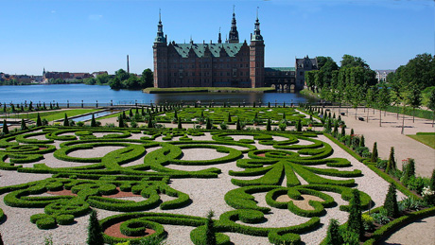
Denmark is also a monarchy. The monarchy has existed since 958, where the Danish king Gorm Den Gamle (in English: Gorm The Old) created the monarchy. Today, we have a queen, who in many ways is the representative of Denmark. The queen, or the king, has to sign every law in Denmark, before it is legitimate – but they actually don’t have any authority. If the queen refuses to sign a law, she is dismissed as the queen of Denmark. The queen is also required to be a member of the protestant church, as Protestantism is the official religion of Denmark.
Frederiksborg Castle

The Danish citizens have been declared the happiest people on earth in 2012, which we in Denmark and many other people around the world think is quite a success since the weather, almost all year around, is not very prone to make anybody happy – we have very harsh winters, where the temperature rarely passes 5 degrees.
The winter, which often brings snow, is an obstacle to one of the things that is most special about Denmark – to cycle. Almost every citizen who lives in a bigger city uses his or her bike every day, and Copenhagen, the capital of Denmark, has been declared the best city to cycle in the world.

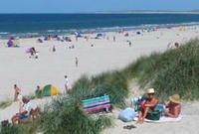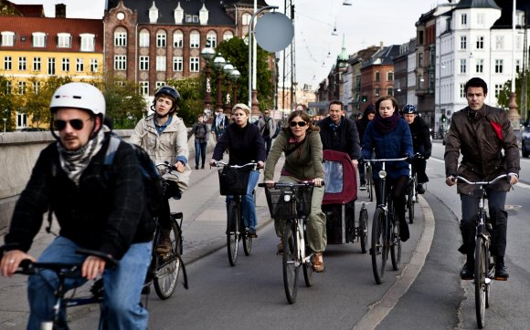

Besides cycling, some of the characteristics about Denmark is: Hans Christian Andersen, a lot of shore line, the Danish beer company Carlsberg, the additional letters “Æ, Ø and Å”, production of the worlds best bacon and butter, Danish Pastry, the Danish word “hyggelig”, which there is no direct translation for in English but is a combination of cosy, fun and having a good time (it is often also included eating), flat land, alternative energy mostly in the form of windmills.
How to become a Danish citizen
There are five different ways of becoming a Danish citizen but only one if you are not either born in Denmark, living in a member state of the European Union or adopted to Denmark under the age of 12. The last one is to become a Danish citizen by naturalisation, that is, by statute. Then you may have to apply for Danish nationality. If you apply for Danish nationality this way, you have to satisfy a number of conditions laid down by the Parliament and in Danish the parliament is called Folketinget, pronounced [ˈfʌlgəˌteŋˀ].
If you satisfy those conditions, you will be listed in a naturalisation bill. You will become a Danish national when the bill has been adopted and the act has entered into force. This is called becoming a Danish national by naturalisation.
For an applicant from outside the European Union, there are several conditions that have to be met if an application for permanent residence in Danmark is to be accepted.
- You must swear allegiance to Denmark and declare willingness to observe Danish legislation and law.
- You must renounce your present nationality in order to be listed in a naturalization bill. To meet this condition you may have to apply to your current state government to be released from your present nationality.
- You must report all former criminal offences, no matter how minor.
- You must have a permanent residence permit for Denmark.
- You must not have committed any punished violation of Part 12 and/or 13 – offences against national security, independence, Constitution and supreme authorities of the State.
- You must not have overdue debt to public authorities.
- You must be self-supporting; you must not have received public benefits for more than a total of six months for the in the last five years.
- You must submit a certificate from a Danish language school with an average mark of at least 4 on the 7-step scale.
- You must submit a certificate of passing the Danish social and cultural citizenship test.

